Types of Phrases
# Source: AI Source: Provided by: [Data Path: Persons Table -> ID Column: 1, Name_En Column: Motasem Essam] -> From: [Chatgpt (GPT-4-turbo)] on [7/28/2025]
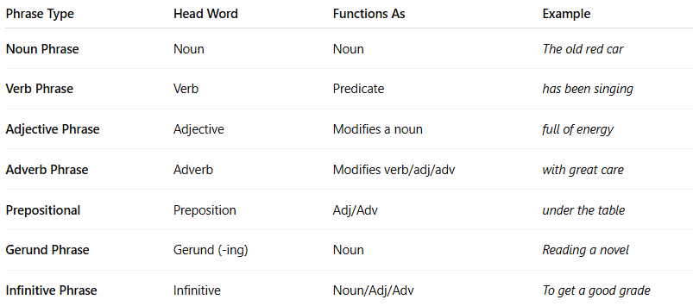

Phrase Type | Head Word | Functions As | Example
Noun Phrase | Noun | Noun | The old red car
Verb Phrase | Verb | Predicate | has been singing
Adjective Phrase | Adjective | Modifies a noun | full of energy
Adverb Phrase | Adverb | Modifies verb/adj/adv | with great care
Prepositional | Preposition | Adj/Adv | under the table
Gerund Phrase | Gerund (-ing) | Noun | Reading a novel
Infinitive Phrase | Infinitive | Noun/Adj/Adv | To get a good grade

